Our chef app's landing page aims to grab the attention of cooking enthusiasts and home chefs. The headline "Culinary courier " tells visitors what our app does right away. It show a lively main image that displays the app's clean look and the great food chefs can make. It then point out main features such as custom meal plans and smart kitchen tools, which show how useful the app is in real life. Comments from happy help build trust it has a log in and sign up buttons . We keep testing different parts of the page and looking at how it performs to make it better and get more chefs to use our app.

The sign-up page for the chef app makes it easy

for new chefs to register. It has a friendly headline

that says, join culinary courier to help users feel

welcome. The form to sign up where the chefs will be asked for key details

such as name, email address, phone number and

password. It also has Confirm Password box to

make sure users type their password .

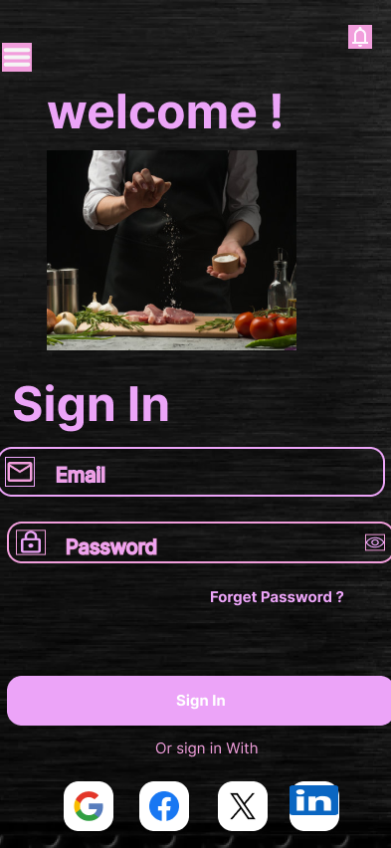

The login page have created for an easy and a secure way for chefs will access their accounts and the application . It has a friendly headline, “Welcome !” Please Sign In to Continue,’ and uncomplicated form with email and password fields where the chef will have to enter their personal information required , For easy login, there is an easily visible ’sign in’ button as well as ‘forgot password’ link that helps the chef recover his or her account details when forgotten. The chef will also be allowed to sign in through social media platforms like Facebook , google , twitter and in link for more convenience.

A menu page with dishes into different categories to help chefs to easily navigate and select their meals on which they will like to add to list made before or start there new list . this is a detailed layout of a menu page featuring Starters, Main Course, and Dessert categories. Where the user have click on one of the icon for the user to be taken to the next page

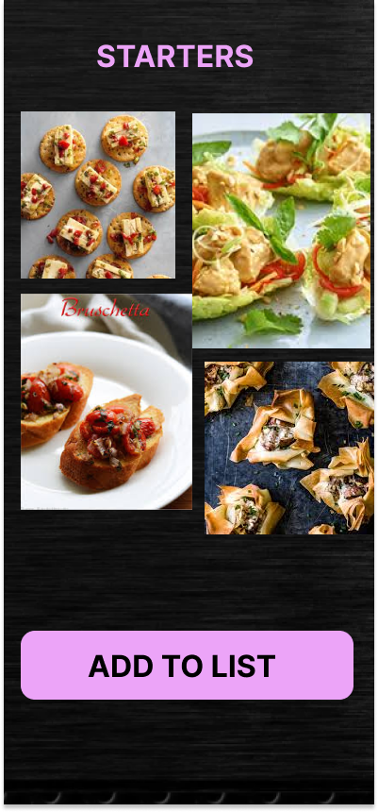

This what you will see after clicking the starters icon , for first use it will show a empty page with a plus sign cause they will not be any items added as yet . else it will show different items already added . the “ add to list button “ allows the chef to add more dishes to the list.

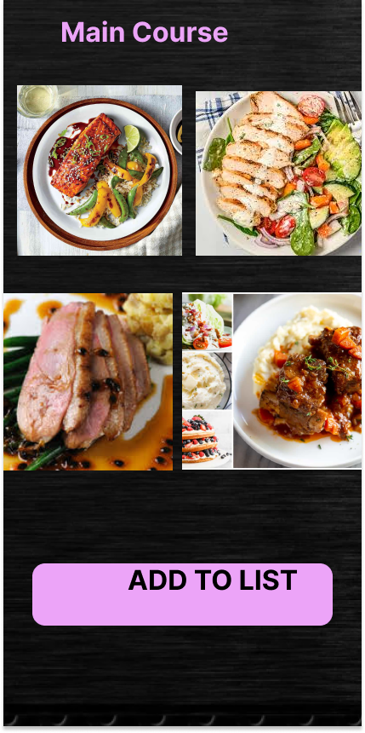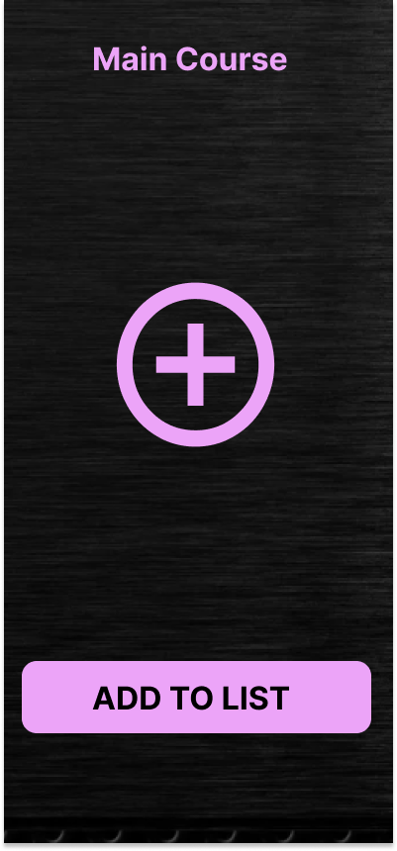  
This is how the next page will look like after clicking the main course icon for first use it will show a empty page with a plus sign cause they will not be any items added as yet . else it will show different items already added . the “ add to list” button allows the chef to add more dishes to the list

This is how the next page will look like after clicking the dessert icon for first use it will show a empty page with a plus sign cause they will not be any items added as yet . else it will show different items already added . the “ add to list” button allows the chef to add more dishes to the list

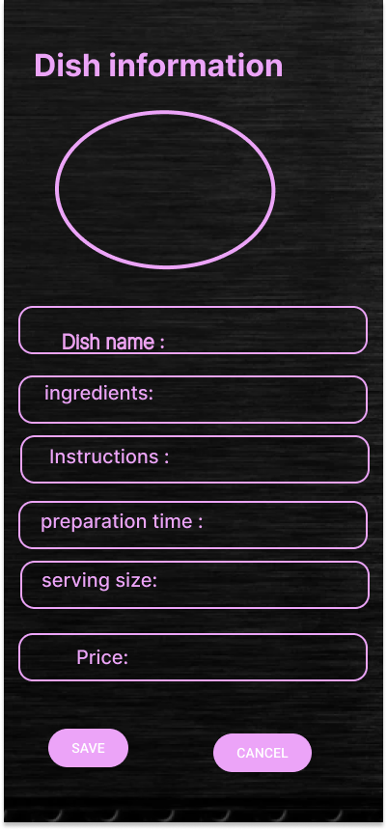

This the screen where the chef will see after clicking the “add to list “ button , this screen will allow the chef to enter the dish name , ingredients , instructions ,preparation time , serving size the price and image of how the dish will look like . The save button will save the information entered and cancel button to erase the information

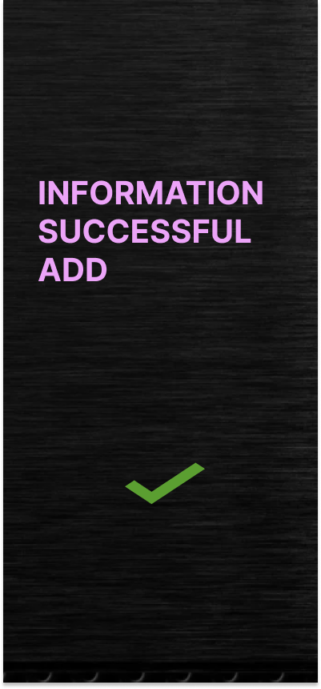

The chef will get a confirmation note after adding the information

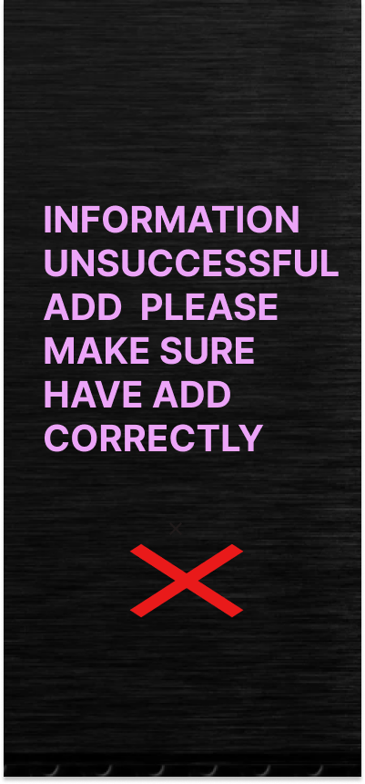

Should the information not correspond it will display an error message